

Configuring an Access Point with WPA and Radius
CCNP Period 6-7, Mr. Mason
Sheen, Alen (Student)

Purpose
Setting up a wireless access point basically lets people connect to a network without needing any cables, which is super handy when you’ve got a bunch of devices moving around or connecting on and off. It’s perfect for places where things aren’t so fixed like in a coffee shop or a busy office.
Take Starbucks, for example. They use wireless access points so customers can hop on the Wi-Fi with their phones or laptops, move around freely, and still stay connected. It’s all about making things easy and flexible no plugging in, no hassle. Whether you're chilling with a coffee, working on your laptop, or just checking your messages, the Wi-Fi is right there when you need it.
Wireless access points make life smoother not just for customers, but also for businesses. They cut down on messy cables and make it way easier to expand or manage the network as things grow or change.
Background Information
Background Information on Lab Concepts
Access Points (APs) are devices that broadcast wireless signals so devices can connect to a network without needing a physical connection like an Ethernet cable. You’ll find them everywhere restaurants, offices, schools pretty much any place that offers Wi-Fi. For example, in Antigua, access points played a key role in setting up Wi-Fi in schools. They made it possible for students to use laptops wirelessly and allowed dozens of devices to connect to the same network. By linking multiple APs to a central switch, we could build a network that reached across classrooms and gave reliable internet access to a large number of students.
To configure the APs, we used the built-in Graphic User Interface (GUI), which made the setup process super straightforward. Through the GUI, we were able to create and manage SSIDs (Service Set Identifiers)—basically, the network names you see when you try to connect to Wi-Fi. This made the setup faster and easier.
Our access point supported different types of network security, each suited to different needs:
- Guest Network: This one had no password, allowing anyone to connect without needing credentials. It’s useful in public spaces or areas where guests need quick access to Wi-Fi without going through a long login process.
- Secure Network (WPA2-PSK): This is what most homes and businesses use. It requires a pre-shared key (basically a password) to connect. It also uses AES encryption to protect data during transmission, which makes it a solid option for everyday use.
- Enterprise Network (RADIUS): We set this one up using FreeRADIUS. This type of security handles user authentication, authorization, and accounting on a central server, which is super useful in larger networks with lots of users. It helps keep things organized and secure.
To take it a step further, we configured VLANs (Virtual LANs) on our switch. VLANs help segment the network to boost performance, security, and manageability. For example, by separating guest traffic from employee traffic, we can apply different rules and keep things running smoothly. The switch connected to both the router and the internet, letting us route traffic efficiently and securely.
Lab Summary
By the end of the lab, we successfully configured a functional access point with three distinct SSIDs, each featuring its own tailored security settings. This setup mirrors real-world scenarios, such as businesses that need to provide separate Wi-Fi access for guests and employees. Gaining hands-on experience in designing and implementing secure, reliable networks is essential for any aspiring network engineer, and this lab provided a valuable opportunity to develop and apply those critical skills.
Lab Commands
R1:
g0/0/0.1: 192.168.1.1 255.255.255.0 vlan 1, native
g0/0/0.10: 192.168.10.1 255.255.255.0 vlan 10
g0/0/0.20: 192.168.20.1 255.255.255.0 vlan 20
g0/0/0.30: 192.168.30.1 255.255.255.0 vlan 30
g0/0/1: dhcp from 192.168.40.0 255.255.255.0
dhcp pool GUEST: network 192.168.10.0 255.255.255.0
dhcp pool SECURE: network 192.168.20.0 255.255.255.0
dhcp pool RADIUS: network 192.168.30.0 255.255.255.0
all pools: dns-server 8.8.8.8, default-router 192.168.1.1
access list:
permit 192.168.1.0 0.0.0.255,
permit 192.168.10.0 0.0.0.255
permit 192.168.20.0 0.0.0.255
permit 192.168.30.0 0.0.0.255
ip nat inside source list 1 int g0/0/1 overload

S1:
enable
configure terminal
hostname aceSwitch
interface vlan 1
ip address 192.168.1.2 255.255.255.0
no shutdown
exit
ip default-gateway 192.168.1.1
vlan 10
name aceGuest
exit
vlan 20
name aceSecure
exit
vlan 30
name aceRadius
exit
interface fastEthernet 0/1
switchport mode trunk
switchport trunk native vlan 1
spanning-tree portfast
exit
interface fastEthernet 0/2
switchport mode access
switchport access vlan 1
spanning-tree portfast
exit
interface fastEthernet 0/22
switchport mode trunk
switchport trunk native vlan 1
spanning-tree portfast
exit
interface fastEthernet 0/23
switchport mode trunk
switchport trunk native vlan 1
spanning-tree portfast
exit
end
AP:
BVI1: 192.168.1.245 255.255.255.0
aceGuest: vlan 10, no encryption
aceSecure: vlan 20, WPA2 PSK, password: 123456789
aceRadius: vlan 30, WPA Enterprise
Radius:
IP: 192.168.1.20
user: ace
password: class
server secret: class
Network Diagram with IP’s
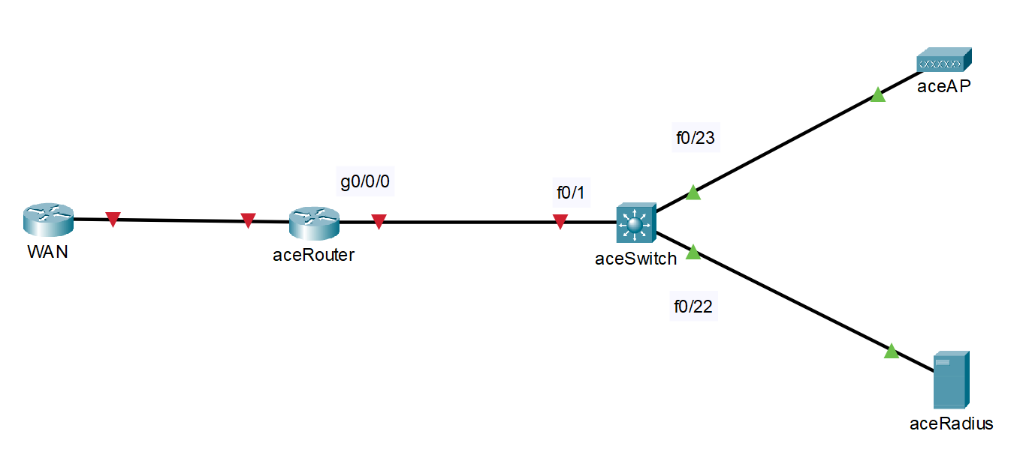

Configurations Show run on all routes involved
Access Point (aceAP)
version 15.3
no service pad
service timestamps debug datetime msec
service timestamps log datetime msec
service password-encryption
hostname ACE
logging rate-limit console 9
enable secret 5 $1$q.Mn$RQDAU5abolsVay.La2vRt1
aaa new-model
aaa group server radius rad_eap
server name 192.168.1.20
aaa group server radius rad_mac
aaa group server radius rad_acct
server name 192.168.1.20
aaa group server radius rad_admin
server name 192.168.1.20
aaa group server tacacs+ tac_admin
aaa group server radius rad_pmip
aaa group server radius dummy
aaa authentication login eap_methods group rad_eap
aaa authentication login mac_methods local
aaa authorization exec default local
aaa accounting network acct_methods start-stop group rad_acct
aaa session-id common
no ip source-route
no ip cef
dot11 pause-time 100
dot11 syslog
dot11 ssid aceGuest
vlan 10
authentication open
guest-mode
dot11 ssid aceRadius
vlan 30
authentication open eap eap_methods
authentication network-eap eap_methods
authentication key-management wpa
mbssid guest-mode
dot11 ssid aceSecure
vlan 20
authentication open
authentication key-management wpa version 2
guest-mode
mbssid guest-mode
wpa-psk ascii 7 08701E1D5D4C53404A52
no ipv6 cef
username Cisco password 7 1531021F0725
bridge irb
interface Dot11Radio0
no ip address
ssid aceGuest
antenna gain 0
station-role root
bridge-group 1
bridge-group 1 subscriber-loop-control
bridge-group 1 spanning-disabled
bridge-group 1 block-unknown-source
no bridge-group 1 source-learning
no bridge-group 1 unicast-flooding
interface Dot11Radio0.10
encapsulation dot1Q 10
bridge-group 10
bridge-group 10 subscriber-loop-control
bridge-group 10 spanning-disabled
bridge-group 10 block-unknown-source
no bridge-group 10 source-learning
no bridge-group 10 unicast-flooding
interface Dot11Radio1
no ip address
encryption vlan 20 mode ciphers aes-ccm
encryption vlan 30 mode ciphers aes-ccm tkip
ssid aceRadius
ssid aceSecure
antenna gain 0
peakdetect
dfs band 3 block
mbssid
channel dfs
station-role root
bridge-group 1
bridge-group 1 subscriber-loop-control
bridge-group 1 spanning-disabled
bridge-group 1 block-unknown-source
no bridge-group 1 source-learning
no bridge-group 1 unicast-flooding
interface Dot11Radio1.20
encapsulation dot1Q 20
bridge-group 20
bridge-group 20 subscriber-loop-control
bridge-group 20 spanning-disabled
bridge-group 20 block-unknown-source
no bridge-group 20 source-learning
no bridge-group 20 unicast-flooding
interface Dot11Radio1.30
encapsulation dot1Q 30
bridge-group 30
bridge-group 30 subscriber-loop-control
bridge-group 30 spanning-disabled
bridge-group 30 block-unknown-source
no bridge-group 30 source-learning
no bridge-group 30 unicast-flooding
interface Dot11Radio1.201
interface GigabitEthernet0
no ip address
duplex auto
speed auto
bridge-group 1
bridge-group 1 spanning-disabled
no bridge-group 1 source-learning
interface GigabitEthernet0.10
encapsulation dot1Q 10
bridge-group 10
bridge-group 10 spanning-disabled
no bridge-group 10 source-learning
interface GigabitEthernet0.20
encapsulation dot1Q 20
bridge-group 20
bridge-group 20 spanning-disabled
no bridge-group 20 source-learning
interface GigabitEthernet0.30
encapsulation dot1Q 30
bridge-group 30
bridge-group 30 spanning-disabled
no bridge-group 30 source-learning
interface GigabitEthernet0.201
interface BVI1
mac-address 44d3.ca03.7dce
ip address 192.168.1.245 255.255.255.0
ipv6 address dhcp
ipv6 address autoconfig
ipv6 enable
ip forward-protocol nd
ip http server
no ip http secure-server
ip http help-path http://www.cisco.com/warp/public/779/smbiz/prodconfig/help/eag
ip radius source-interface BVI1
radius-server attribute 32 include-in-access-req format %h
radius server 192.168.1.20
address ipv4 192.168.1.20 auth-port 1812 acct-port 1813
key 7 121A09160118
bridge 1 route ip
line con 0
line vty 0 4
transport input all
end

Switch (aceSwitch)
version 12.2
no service pad
service timestamps debug datetime msec
service timestamps log datetime msec
no service password-encryption
hostname aceSwitch
boot-start-marker
boot-end-marker
no aaa new-model
system mtu routing 1500
authentication mac-move permit
ip subnet-zero
spanning-tree mode pvst
spanning-tree etherchannel guard misconfig
spanning-tree extend system-id
vlan internal allocation policy ascending
interface FastEthernet0/1
switchport trunk encapsulation dot1q
switchport mode trunk
spanning-tree portfast trunk
interface FastEthernet0/2
switchport mode access
spanning-tree portfast
interface FastEthernet0/3
interface FastEthernet0/4
interface FastEthernet0/
interface FastEthernet0/6
interface FastEthernet0/7
interface FastEthernet0/8
interface FastEthernet0/9
interface FastEthernet0/10
interface FastEthernet0/11
interface FastEthernet0/12
interface FastEthernet0/13
interface FastEthernet0/14
interface FastEthernet0/15
interface FastEthernet0/16
interface FastEthernet0/17
interface FastEthernet0/18
interface FastEthernet0/19
interface FastEthernet0/20
interface FastEthernet0/21
interface FastEthernet0/22
switchport trunk encapsulation dot1q
switchport mode trunk
spanning-tree portfast trunk
interface FastEthernet0/23
switchport trunk encapsulation dot1q
switchport mode trunk
spanning-tree portfast trunk
interface FastEthernet0/24
interface GigabitEthernet0/1
interface GigabitEthernet0/2
interface Vlan1
ip address 192.168.1.2 255.255.255.0
ip classless
ip http server
ip http secure-server
ip sla enable reaction-alerts
line con 0
line vty 5 15
end

Router (aceRouter)
version 15.5
service timestamps debug datetime msec
service timestamps log datetime msec
no platform punt-keepalive disable-kernel-core
hostname aceRouter
boot-start-marker
boot-end-marker
vrf definition Mgmt-intf
address-family ipv4
exit-address-family
address-family ipv6
exit-address-family
no aaa new-model
ip dhcp excluded-address 192.168.1.1 192.168.1.5
ip dhcp excluded-address 192.168.10.1 192.168.10.5
ip dhcp excluded-address 192.168.20.1 192.168.20.5
ip dhcp excluded-address 192.168.30.1 192.168.30.5
ip dhcp excluded-address 192.168.1.20
ip dhcp excluded-address 192.168.1.245
!
ip dhcp pool GUEST
network 192.168.10.0 255.255.255.0
dns-server 8.8.8.8
default-router 192.168.1.1
!
ip dhcp pool SECURE
network 192.168.20.0 255.255.255.0
dns-server 8.8.8.8
default-router 192.168.1.1
ip dhcp pool RADIUS
network 192.168.30.0 255.255.255.0
dns-server 8.8.8.8
default-router 192.168.1.1
subscriber templating
vtp domain cisco
vtp mode transparent
multilink bundle-name authenticated
license udi pid ISR4321/K9 sn FDO21281AAT
spanning-tree extend system-id
redundancy
mode none
vlan internal allocation policy ascending
interface GigabitEthernet0/0/0
no ip address
negotiation auto
interface GigabitEthernet0/0/0.1
encapsulation dot1Q 1 native
ip address 192.168.1.1 255.255.255.0
ip nat inside
interface GigabitEthernet0/0/0.10
encapsulation dot1Q 10
ip address 192.168.10.1 255.255.255.0
ip nat inside
interface GigabitEthernet0/0/0.20
encapsulation dot1Q 20
ip address 192.168.20.1 255.255.255.0
ip nat inside
interface GigabitEthernet0/0/0.30
encapsulation dot1Q 30
ip address 192.168.30.1 255.255.255.0
ip nat inside
interface GigabitEthernet0/0/1
ip address dhcp
ip nat outside
negotiation auto
interface GigabitEthernet0/1/0
negotiation auto
interface GigabitEthernet0/1/1
negotiation auto
interface Service-Engine0/2/0
no ip address
interface GigabitEthernet0
vrf forwarding Mgmt-intf
no ip address
shutdown
negotiation auto
interface Vlan1
no ip address
shutdown
ip nat inside source list 1 interface GigabitEthernet0/0/1 overload
ip forward-protocol nd
no ip http server
no ip http secure-server
ip tftp source-interface GigabitEthernet0
access-list 1 permit 192.168.1.0 0.0.0.255
access-list 1 permit 192.168.10.0 0.0.0.255
access-list 1 permit 192.168.20.0 0.0.0.255
access-list 1 permit 192.168.30.0 0.0.0.255
control-plane
line con 0
stopbits 1
line aux 0
stopbits 1
line vty 0 4
login
end
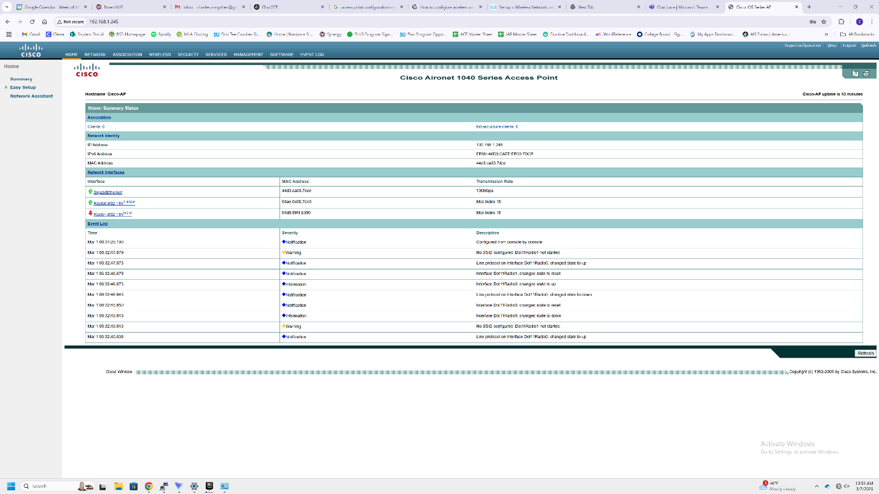
Access Point GUI Summary

Problems
Problems Encountered
- Bootloader Loop After Factory Reset
After performing a factory reset on the access point, it got stuck in the bootloader. It appeared to be trying to boot using the images:
  - flash:/c1140-k9w7-xx.153-3.JD9/c1140-k9w7-xx.153-3.JD9
  - flash:/c1140-k9w7-mx.153-3.JD9/c1140-k9w7-mx.153-3.JD9
The first image seemed corrupted due to its small size, and the second image directory didn’t exist. We later discovered the correct image was actually located at:
flash:/c1140-k9w7-mx.153-3.JD9/c1140-k9w7-xx.153-3.JD9
To fix the issue, we set the BOOT environmental variable to point to the correct path, allowing the access point to boot successfully.
- Topology Limitation (No Router-on-a-Stick)
Our original network design only included a Layer 3 switch instead of using both a switch and a router. This limited our ability to implement router-on-a-stick—a setup that simplifies VLAN routing and allows better segmentation and inter-VLAN communication. It also would’ve made IP address management within VLANs easier.
- Native VLAN Mismatch
We ran into issues with mismatched native VLANs between the router/switch and the access point. This caused some tagged traffic to be treated as untagged, leading to connectivity issues and even loss of administrative access to the access point at certain points. We resolved this by carefully reviewing and cleaning up our VLAN configurations across all devices.
- Incorrect RADIUS Client Configuration
In our initial FreeRADIUS setup, we added a general private network range in the clients.conf file. However, the correct approach was to explicitly define a client entry using the actual IP address of the access point. Once we made this adjustment, RADIUS communication worked as expected.
- Enterprise SSID Not Binding to RADIUS Server
When setting up the WPA Enterprise SSID, the default configuration didn’t bind the SSID to the RADIUS server. Although the server details were entered, the access point wasn’t actually using the server for authentication. We had to manually link the WPA Enterprise SSID to the RADIUS server in order to get authentication working properly.
- Incorrect RADIUS Port Numbers
By default, the access point was using ports 1645 for authentication and 1646 for accounting. However, FreeRADIUS typically uses ports 1812 and 1813. Once we updated the access point to use the correct ports, the server started processing authentication requests as expected.
Conclusion
This lab was a great opportunity to dive deeper into configuring access points, which are super relevant in real-world networking. It was especially cool to connect what we learned with how access points were actually set up and used in the schools back in Antigua. Seeing how they played a role in providing internet access to students made the whole experience feel even more meaningful.
Since access points are everywhere in homes, businesses, and public places—learning how to configure them properly is a valuable skill to have. Whether it's setting up a secure network for a company or just troubleshooting a home Wi-Fi setup, the knowledge we gained here can definitely come in handy in a lot of situations.

Teacher Signoff Page of Lab Complete.
